PRACTICAL: 2

Objective:

To develop clean and accessibility-ready HTML5 structures for StudentHub pages using semantic elements, proper navigation, and accessible content organization.

Theory:

- HTML5 semantic elements such as <header>, <nav>, <main>, <section>, <article>, <aside>, and
<footer> provide a meaningful structure to webpages.
- Proper headings, form labels, image alt text, and navigation links improve accessibility.
- Consistent page structure makes the website easier to understand and maintain.
- HTML pages can be linked together using navigation links to create a connected StudentHub portal.

Student Hub

HTML Pages:

  - index.html – Home
  - about.html – About
  - register.html – Register
  - login.html – Login
  - dashboard.html – Dashboard
  - events.html – Events
  - profile.html – Profile
  - contact.html – Contact
  - admin.html – Admin
  - faq.html – FAQ
  - feedback.html – Feedback

Code:
Home:Index.html
<!DOCTYPE html>
<html lang="en">
<head>
<meta charset="UTF-8">
<meta name="viewport" content="width=device-width, initial-scale=1.0">
<title>StudentHub | Home</title>
</head>

<body>

<a href="#main-content">Skip to main content</a>

<header>
<h1>StudentHub</h1>

<p>Student Information and Campus Portal</p>

<nav aria-label="Primary navigation">
<ul>
<li><a href="index.html" aria-current="page">Home</a></li>
<li><a href="about.html">About</a></li>
<li><a href="events.html">Events</a></li>
<li><a href="dashboard.html">Dashboard</a></li>
<li><a href="profile.html">Profile</a></li>
<li><a href="contact.html">Contact</a></li>
<li><a href="faq.html">FAQ</a></li>
<li><a href="feedback.html">Feedback</a></li>
<li><a href="login.html">Login</a></li>
<li><a href="register.html">Register</a></li>
</ul>
</nav>
</header>

<main id="main-content">

<nav aria-label="Breadcrumb">
<ol>
<li><a href="index.html">Home</a></li>
</ol>
</nav>

<section>
<h2>Welcome to StudentHub</h2>

<p>
StudentHub is a student portal that provides information about
academics, campus events, student activities, and services.
</p>

</section>

<section>
<h2>Student Services</h2>

<article>
<h3>Academic Information</h3>
<p>
Access academic information, schedules, and important
student resources.
</p>
</article>

<article>
<h3>Campus Events</h3>
<p>
Explore upcoming workshops, seminars, competitions,
and campus activities.
</p>
</article>

<article>
<h3>Student Community</h3>
<p>
Stay connected with students and campus organizations.
</p>
</article>
</section>

<aside>
<h2>Important Notice</h2>
<p>
Students should regularly check the portal for announcements
and upcoming events.
</p>
</aside>

</main>

<footer>
<p>&copy; 2026 StudentHub. All rights reserved.</p>

<address>
Email:
<a href="mailto:info@studenthub.example">
info@studenthub.example
</a>
</address>
</footer>

</body>
</html>

About: about.html

<!DOCTYPE html>
<html lang="en">
<head>
<meta charset="UTF-8">
<meta name="viewport" content="width=device-width, initial-scale=1.0">
<title>StudentHub | About</title>
</head>

<body>

<a href="#main-content">Skip to main content</a>

<header>
<h1>StudentHub</h1>

<nav aria-label="Primary navigation">
<ul>
<li><a href="index.html">Home</a></li>
<li><a href="about.html" aria-current="page">About</a></li>
<li><a href="events.html">Events</a></li>
<li><a href="dashboard.html">Dashboard</a></li>
<li><a href="profile.html">Profile</a></li>
<li><a href="contact.html">Contact</a></li>
<li><a href="faq.html">FAQ</a></li>
<li><a href="feedback.html">Feedback</a></li>
<li><a href="login.html">Login</a></li>
<li><a href="register.html">Register</a></li>
</ul>
</nav>
</header>

<main id="main-content">

<nav aria-label="Breadcrumb">
<ol>
<li><a href="index.html">Home</a></li>
<li aria-current="page">About</li>
</ol>
</nav>

<section>
<h2>About StudentHub</h2>

<p>
StudentHub is a centralized platform designed to provide
students with easy access to campus information and services.
</p>
</section>

<section>
<h2>Our Mission</h2>

<article>
<h3>Student Support</h3>
<p>
Our goal is to make student information easy to access
and understand.
</p>
</article>

<article>
<h3>Digital Learning</h3>
<p>
StudentHub supports digital access to academic and
campus resources.
</p>
</article>
</section>

<aside>
<h2>Our Values</h2>
<ul>
<li>Accessibility</li>
<li>Student Support</li>
<li>Innovation</li>
<li>Community</li>
</ul>
</aside>

</main>

<footer>
<p>&copy; 2026 StudentHub. All rights reserved.</p>
</footer>

</body>
</html>

Register :register.html
<!DOCTYPE html>
<html lang="en">

<head>
<meta charset="UTF-8">
<meta name="viewport" content="width=device-width, initial-scale=1.0">
<title>StudentHub | Register</title>
</head>

<body>

<a href="#main-content">Skip to main content</a>

<header>
<h1>StudentHub</h1>

<nav aria-label="Primary navigation">
<ul>
<li><a href="index.html">Home</a></li>
<li><a href="about.html">About</a></li>
<li><a href="events.html">Events</a></li>
<li><a href="dashboard.html">Dashboard</a></li>
<li><a href="profile.html">Profile</a></li>
<li><a href="contact.html">Contact</a></li>
<li><a href="faq.html">FAQ</a></li>
<li><a href="feedback.html">Feedback</a></li>
<li><a href="login.html">Login</a></li>
<li>
<a href="register.html" aria-current="page">
Register
</a>
</li>
</ul>
</nav>
</header>

<main id="main-content">

<nav aria-label="Breadcrumb">
<ol>
<li>
<a href="index.html">Home</a>
</li>
<li aria-current="page">
Register
</li>
</ol>
</nav>

<section>
<h2>Create Student Account</h2>

<form action="#" method="post">

<fieldset>
<legend>Personal Information</legend>

<p>
<label for="full-name">
Full Name
</label>

<input
type="text"
id="full-name"
name="full-name"
required>
</p>

<p>
<label for="email">
Email Address
</label>

<input
type="email"
id="email"
name="email"
required>
</p>

<p>
<label for="mobile">
Mobile Number
</label>

<input
type="tel"
id="mobile"
name="mobile"
required>
</p>

</fieldset>

<fieldset>
<legend>Academic Information</legend>

<p>
<label for="program">
Program
</label>

<select
id="program"
name="program"
required>

<option value="">
Select Program
</option>

<option value="aiml">
Artificial Intelligence and Machine Learning
</option>

<option value="computer-engineering">
Computer Engineering
</option>

<option value="information-technology">
Information Technology
</option>

</select>
</p>

<p>
<label for="semester">
Semester
</label>

<input
type="number"
id="semester"
name="semester"
min="1"
max="8"
required>
</p>

</fieldset>

<fieldset>
<legend>Account Security</legend>

<p>
<label for="password">
Password
</label>

<input
type="password"
id="password"
name="password"
required>
</p>

<p>
<label for="confirm-password">
Confirm Password
</label>

<input
type="password"
id="confirm-password"
name="confirm-password"
required>
</p>

</fieldset>

<button type="submit">
Create Account
</button>

<button type="reset">
Clear Form
</button>

</form>

</section>

</main>

<footer>
<p>
&copy; 2026 StudentHub. All rights reserved.
</p>
</footer>

</body>

</html>

Login: login.html

<!DOCTYPE html>
<html lang="en">
<head>
<meta charset="UTF-8">
<meta name="viewport" content="width=device-width, initial-scale=1.0">
<title>StudentHub | Login</title>
</head>

<body>

<a href="#main-content">Skip to main content</a>

<header>
<h1>StudentHub</h1>

<nav aria-label="Primary navigation">
<ul>
<li><a href="index.html">Home</a></li>
<li><a href="about.html">About</a></li>
<li><a href="events.html">Events</a></li>
<li><a href="dashboard.html">Dashboard</a></li>
<li><a href="profile.html">Profile</a></li>
<li><a href="contact.html">Contact</a></li>
<li><a href="faq.html">FAQ</a></li>
<li><a href="feedback.html">Feedback</a></li>
<li><a href="login.html" aria-current="page">Login</a></li>
<li><a href="register.html">Register</a></li>
</ul>
</nav>
</header>

<main id="main-content">

<nav aria-label="Breadcrumb">
<ol>
<li><a href="index.html">Home</a></li>
<li aria-current="page">Login</li>
</ol>
</nav>

<section>
<h2>Student Login</h2>

<p>
Login to access your StudentHub account.
</p>

<form action="#" method="post">

<fieldset>
<legend>Login Information</legend>

<p>
<label for="email">Email Address</label>
<input
type="email"
id="email"
name="email"
autocomplete="email"
required>
</p>

<p>
<label for="password">Password</label>
<input
type="password"
id="password"
name="password"
autocomplete="current-password"
required>
</p>

<p>
<input
type="checkbox"
id="remember"
name="remember">

<label for="remember">
Remember me
</label>
</p>

</fieldset>

<button type="submit">Login</button>
<button type="reset">Clear</button>

</form>

<p>
Don't have an account?
<a href="register.html">Register here</a>
</p>

</section>

</main>

<footer>
<p>&copy; 2026 StudentHub. All rights reserved.</p>
</footer>

</body>
</html>

Dashboard: dashboard.html
<!DOCTYPE html>
<html lang="en">
<head>
<meta charset="UTF-8">
<meta name="viewport" content="width=device-width, initial-scale=1.0">
<title>StudentHub | Dashboard</title>
</head>

<body>

<a href="#main-content">Skip to main content</a>

<header>
<h1>StudentHub Dashboard</h1>

<nav aria-label="Primary navigation">
<ul>
<li><a href="index.html">Home</a></li>
<li><a href="about.html">About</a></li>
<li><a href="events.html">Events</a></li>
<li><a href="dashboard.html" aria-current="page">Dashboard</a></li>
<li><a href="profile.html">Profile</a></li>
<li><a href="contact.html">Contact</a></li>
<li><a href="faq.html">FAQ</a></li>
<li><a href="feedback.html">Feedback</a></li>
</ul>
</nav>
</header>

<main id="main-content">

<nav aria-label="Breadcrumb">
<ol>
<li><a href="index.html">Home</a></li>
<li aria-current="page">Dashboard</li>
</ol>
</nav>

<section>
<h2>Welcome, Student</h2>

<p>
This dashboard provides quick access to student information.
</p>
</section>

<section>
<h2>Academic Overview</h2>

<table>
<caption>Current academic information</caption>

<thead>
<tr>
<th scope="col">Subject</th>
<th scope="col">Credits</th>
<th scope="col">Status</th>
</tr>
</thead>

<tbody>
<tr>
<td>Programming</td>
<td>4</td>
<td>In Progress</td>
</tr>

<tr>
<td>Database Systems</td>
<td>4</td>
<td>In Progress</td>
</tr>

<tr>
<td>Web Technology</td>
<td>3</td>
<td>Completed</td>
</tr>
</tbody>
</table>
</section>

<aside>
<h2>Quick Links</h2>

<ul>
<li><a href="events.html">View Events</a></li>
<li><a href="profile.html">Update Profile</a></li>
<li><a href="feedback.html">Submit Feedback</a></li>
</ul>
</aside>

</main>

<footer>
<p>&copy; 2026 StudentHub. All rights reserved.</p>
</footer>

</body>
</html>

Events: events.html

<!DOCTYPE html>
<html lang="en">
<head>
<meta charset="UTF-8">
<meta name="viewport" content="width=device-width, initial-scale=1.0">
<title>StudentHub - Events</title>
</head>

<body>

<main id="main-content">

<nav aria-label="Breadcrumb">
<ol>
<li><a href="index.html">Home</a></li>
<li aria-current="page">Events</li>
</ol>
</nav>

<section>
<h2>Upcoming Events</h2>

<article>
<h3>AI and Machine Learning Workshop</h3>

<p>
Date:
<time datetime="2026-08-15">15 August 2026</time>
</p>

<p>
Learn the fundamentals of artificial intelligence
and machine learning.
</p>

<p>
<a href="register.html">Register for workshop</a>
</p>
</article>

<article>
<h3>Student Innovation Competition</h3>

<p>
Date:
<time datetime="2026-08-22">22 August 2026</time>
</p>

<p>
Students can present innovative technology-based ideas.
</p>

<p>
<a href="register.html">Register for competition</a>
</p>
</article>

<article>
<h3>Campus Coding Challenge</h3>

<p>
Date:
<time datetime="2026-09-05">5 September 2026</time>
</p>

<p>
Test programming and problem-solving skills in a coding event.
</p>
</article>

</section>

</main>

<footer>
<p>&copy; 2026 StudentHub. All rights reserved.</p>
</footer>

</body>
</html>

Profile: profile.html
<!DOCTYPE html>
<html lang="en">

<head>
<meta charset="UTF-8">
<meta name="viewport" content="width=device-width, initial-scale=1.0">
<title>StudentHub | Profile</title>
</head>

<body>

<a href="#main-content">Skip to main content</a>

<header>
<h1>StudentHub</h1>

<nav aria-label="Primary navigation">
<ul>
<li><a href="index.html">Home</a></li>
<li><a href="about.html">About</a></li>
<li><a href="events.html">Events</a></li>
<li><a href="dashboard.html">Dashboard</a></li>
<li>
<a href="profile.html" aria-current="page">
Profile
</a>
</li>
<li><a href="contact.html">Contact</a></li>
<li><a href="faq.html">FAQ</a></li>
<li><a href="feedback.html">Feedback</a></li>
</ul>
</nav>
</header>

<main id="main-content">

<nav aria-label="Breadcrumb">
<ol>
<li>
<a href="index.html">Home</a>
</li>
<li aria-current="page">
Profile
</li>
</ol>
</nav>

<section>
<h2>Student Profile</h2>

<dl>

<dt>Name</dt>
<dd>Krina Sorathiya</dd>

<dt>Email</dt>
<dd>
<a href="mailto:25aiml071@charusat.edu.in">
25aiml071@charusat.edu.in
</a>
</dd>

<dt>Program</dt>
<dd>
Artificial Intelligence and Machine Learning
</dd>

<dt>Semester</dt>
<dd>3</dd>

</dl>
</section>

<section>
<h2>Skills</h2>

<ul>
<li>Python</li>
<li>HTML5</li>
<li>Problem Solving</li>
<li>Machine Learning Fundamentals</li>
<li>Data Structure and algorithm</li>
</ul>
</section>

</main>

<footer>
<p>
&copy; 2026 StudentHub. All rights reserved.
</p>
</footer>

</body>

</html>

Contact: contact.html

<!DOCTYPE html>
<html lang="en">
<head>
<meta charset="UTF-8">
<meta name="viewport" content="width=device-width, initial-scale=1.0">
<title>StudentHub | Contact</title>
</head>

<body>

<a href="#main-content">Skip to main content</a>

<header>
<h1>StudentHub</h1>

<nav aria-label="Primary navigation">
<ul>
<li><a href="index.html">Home</a></li>
<li><a href="about.html">About</a></li>
<li><a href="events.html">Events</a></li>
<li><a href="dashboard.html">Dashboard</a></li>
<li><a href="profile.html">Profile</a></li>
<li><a href="contact.html" aria-current="page">Contact</a></li>
<li><a href="faq.html">FAQ</a></li>
<li><a href="feedback.html">Feedback</a></li>
</ul>
</nav>
</header>

<main id="main-content">

<nav aria-label="Breadcrumb">
<ol>
<li><a href="index.html">Home</a></li>
<li aria-current="page">Contact</li>
</ol>
</nav>

<section>
<h2>Contact StudentHub</h2>

<address>
StudentHub Support Centre<br>
University Campus<br>
Email:
<a href="mailto:support@studenthub.example">
support@studenthub.example
</a><br>
Phone:
<a href="tel:+919265896854">
+91 123659874
</a>
</address>
</section>

<section>
<h2>Send an Enquiry</h2>

<form action="#" method="post">

<p>
<label for="name">Full Name</label>
<input
type="text"
id="name"
name="name"
required>
</p>

<p>
<label for="contact-email">Email Address</label>
<input
type="email"
id="contact-email"
name="email"
required>
</p>

<p>
<label for="subject">Subject</label>
<input
type="text"
id="subject"
name="subject"
required>
</p>

<p>
<label for="message">Message</label>
<textarea
id="message"
name="message"
rows="6"
cols="40"
required></textarea>
</p>

<button type="submit">Send Enquiry</button>
<button type="reset">Clear</button>

</form>
</section>

</main>

<footer>
<p>&copy; 2026 StudentHub. All rights reserved.</p>
</footer>

</body>
</html>

Admin: admin.html

<!DOCTYPE html>
<html lang="en">
<head>
<meta charset="UTF-8">
<meta name="viewport" content="width=device-width, initial-scale=1.0">
<title>StudentHub | Admin</title>
</head>

<body>

<a href="#main-content">Skip to main content</a>

<header>
<h1>StudentHub Administration</h1>

<nav aria-label="Administrative navigation">
<ul>
<li><a href="index.html">Home</a></li>
<li><a href="dashboard.html">Dashboard</a></li>
<li><a href="events.html">Events</a></li>
<li><a href="admin.html" aria-current="page">Admin</a></li>
<li><a href="contact.html">Contact</a></li>
</ul>
</nav>
</header>

<main id="main-content">

<nav aria-label="Breadcrumb">
<ol>
<li><a href="index.html">Home</a></li>
<li aria-current="page">Admin</li>
</ol>
</nav>

<section>
<h2>Administration Dashboard</h2>

<article>
<h3>Student Management</h3>

<p>
Manage student records and review registered students.
</p>

<a href="profile.html">View Student Profiles</a>
</article>

<article>
<h3>Event Management</h3>

<p>
Review and manage upcoming student events.
</p>

<a href="events.html">View Events</a>
</article>

<article>
<h3>Feedback Management</h3>

<p>
Review feedback submitted by students.
</p>

<a href="feedback.html">View Feedback</a>
</article>
</section>

<section>
<h2>Student Summary</h2>

<table>
<caption>Student statistics</caption>

<thead>
<tr>
<th scope="col">Category</th>
<th scope="col">Count</th>
<th scope="col">Status</th>
</tr>
</thead>

<tbody>
<tr>
<td>Registered Students</td>
<td>250</td>
<td>Active</td>
</tr>

<tr>
<td>Upcoming Events</td>
<td>8</td>
<td>Scheduled</td>
</tr>

<tr>
<td>Pending Feedback</td>
<td>12</td>
<td>Review Required</td>
</tr>
</tbody>
</table>
</section>

</main>

<footer>
<p>&copy; 2026 StudentHub. All rights reserved.</p>
</footer>

</body>
</html>

FAQ: faq.html
<!DOCTYPE html>
<html lang="en">
<head>
<meta charset="UTF-8">
<meta name="viewport" content="width=device-width, initial-scale=1.0">
<title>StudentHub | FAQ</title>
</head>

<body>

<a href="#main-content">Skip to main content</a>

<header>
<h1>StudentHub</h1>

<nav aria-label="Primary navigation">
<ul>
<li><a href="index.html">Home</a></li>
<li><a href="about.html">About</a></li>
<li><a href="events.html">Events</a></li>
<li><a href="dashboard.html">Dashboard</a></li>
<li><a href="profile.html">Profile</a></li>
<li><a href="contact.html">Contact</a></li>
<li><a href="faq.html" aria-current="page">FAQ</a></li>
<li><a href="feedback.html">Feedback</a></li>
</ul>
</nav>
</header>

<main id="main-content">

<nav aria-label="Breadcrumb">
<ol>
<li><a href="index.html">Home</a></li>
<li aria-current="page">FAQ</li>
</ol>
</nav>

<section>
<h2>Frequently Asked Questions</h2>

<article>
<details>
<summary>What is StudentHub?</summary>
<p>
StudentHub is a student portal providing access
to academic and campus information.
</p>
</details>
</article>

<article>
<details>
<summary>How can I create an account?</summary>
<p>
Open the Register page and complete the registration form.
</p>
</details>
</article>

<article>
<details>
<summary>How can I view campus events?</summary>
<p>
Select the Events option from the navigation menu.
</p>
</details>
</article>

<article>
<details>
<summary>How can I contact StudentHub?</summary>
<p>
Visit the Contact page to send an enquiry.
</p>
</details>
</article>

</section>

</main>

<footer>
<p>&copy; 2026 StudentHub. All rights reserved.</p>
</footer>

</body>
</html>

Feedback: feedback.html
<!DOCTYPE html>
<html lang="en">
<head>
<meta charset="UTF-8">
<meta name="viewport" content="width=device-width, initial-scale=1.0">
<title>StudentHub | Feedback</title>
</head>

<body>

<a href="#main-content">Skip to main content</a>

<header>
<h1>StudentHub</h1>

<nav aria-label="Primary navigation">
<ul>
<li><a href="index.html">Home</a></li>
<li><a href="about.html">About</a></li>
<li><a href="events.html">Events</a></li>
<li><a href="dashboard.html">Dashboard</a></li>
<li><a href="profile.html">Profile</a></li>
<li><a href="contact.html">Contact</a></li>
<li><a href="faq.html">FAQ</a></li>
<li><a href="feedback.html" aria-current="page">Feedback</a></li>
</ul>
</nav>
</header>

<main id="main-content">

<nav aria-label="Breadcrumb">
<ol>
<li><a href="index.html">Home</a></li>
<li aria-current="page">Feedback</li>
</ol>
</nav>

<section>
<h2>Student Feedback</h2>

<p>
Your feedback helps improve the StudentHub experience.
</p>

<form action="#" method="post">

<fieldset>
<legend>Feedback Information</legend>

<p>
<label for="feedback-name">Name</label>
<input
type="text"
id="feedback-name"
name="name"
required>
</p>

<p>
<label for="feedback-email">Email</label>
<input
type="email"
id="feedback-email"
name="email"
required>
</p>

<p>
<label for="rating">Overall Rating</label>
<select id="rating" name="rating" required>
<option value="">Select Rating</option>
<option value="5">Excellent</option>
<option value="4">Very Good</option>
<option value="3">Good</option>
<option value="2">Needs Improvement</option>
<option value="1">Poor</option>
</select>
</p>

<p>
<label for="feedback-message">
Your Feedback
</label>

<textarea
id="feedback-message"
name="feedback"
rows="6"
cols="40"
required></textarea>
</p>

</fieldset>

<button type="submit">Submit Feedback</button>
<button type="reset">Clear Form</button>

</form>

</section>

</main>

<footer>
<p>&copy; 2026 StudentHub. All rights reserved.</p>
</footer>

</body>
</html>

Output:

Home Page
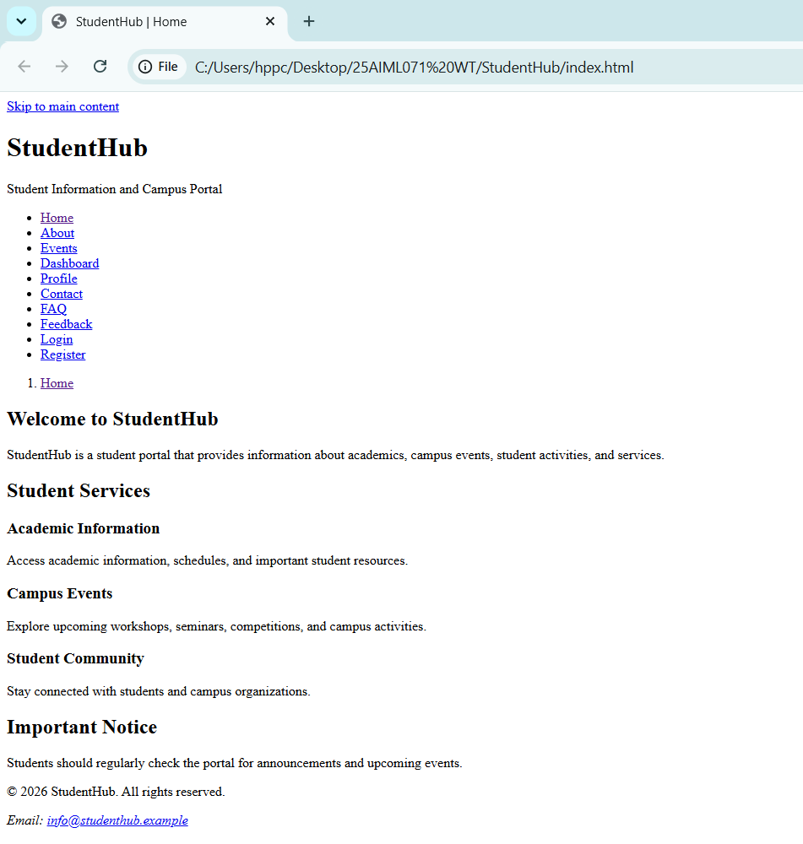

About Page

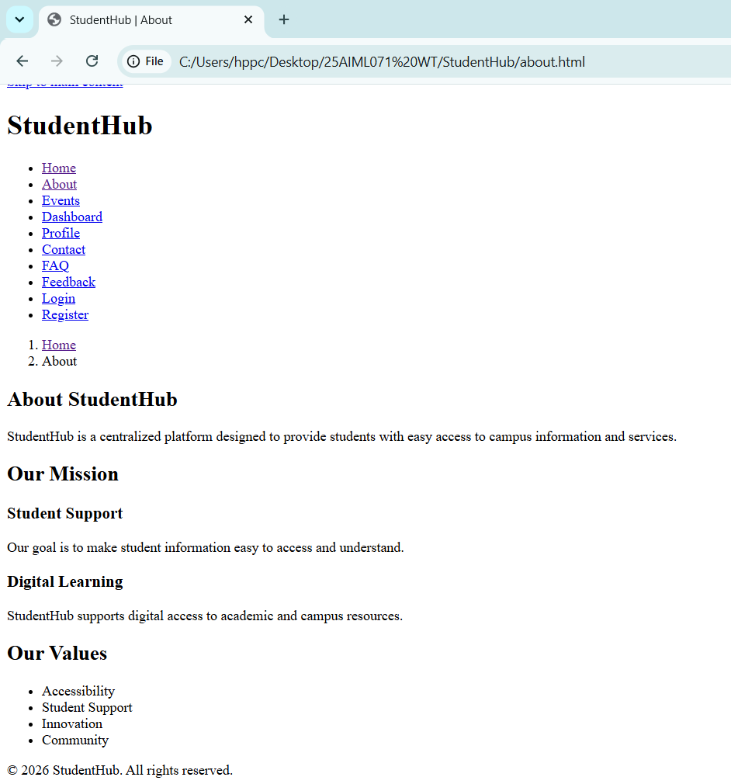

Events

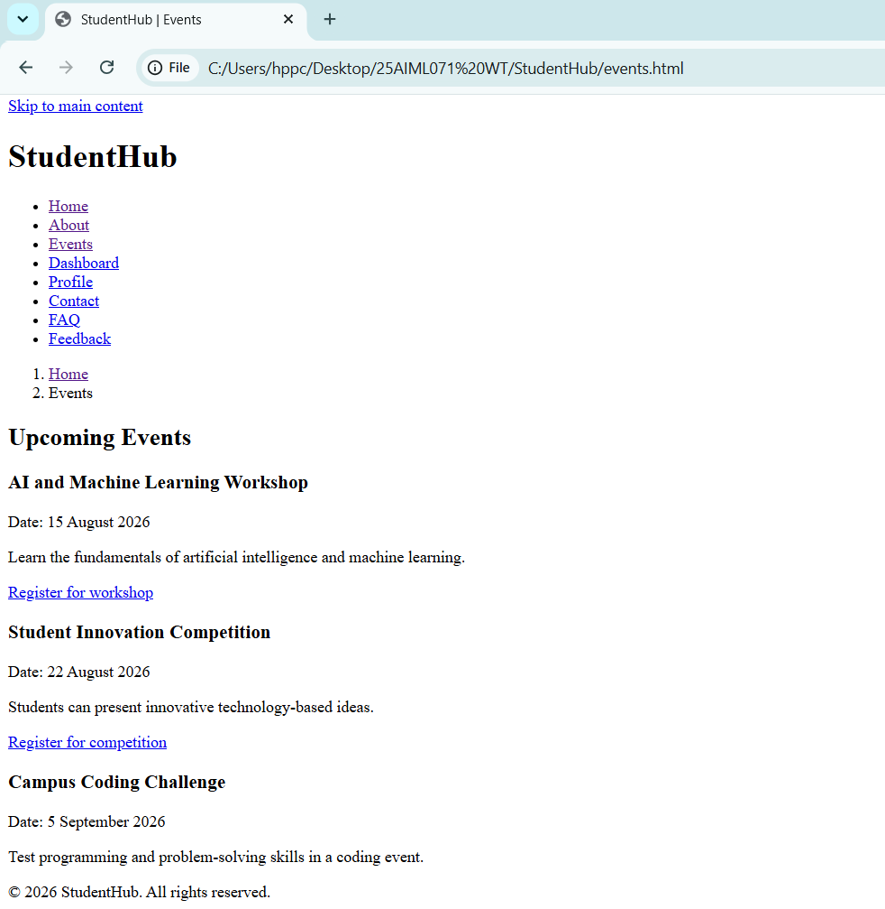

Login

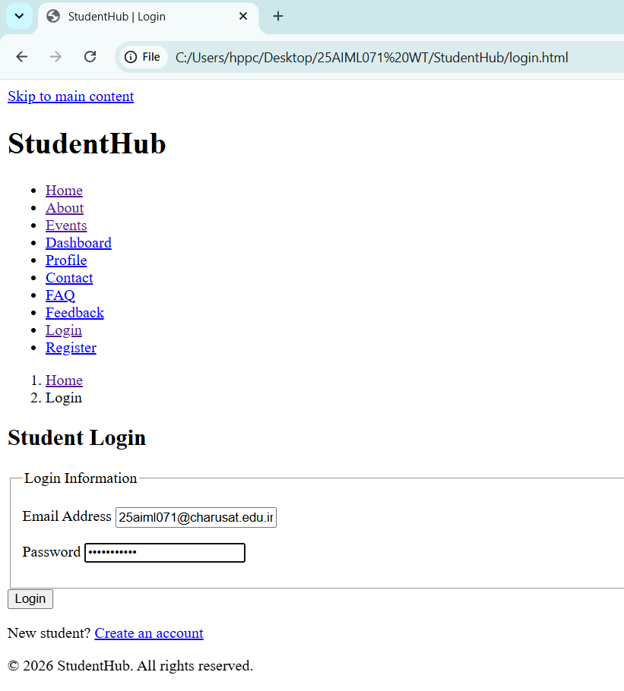

Register

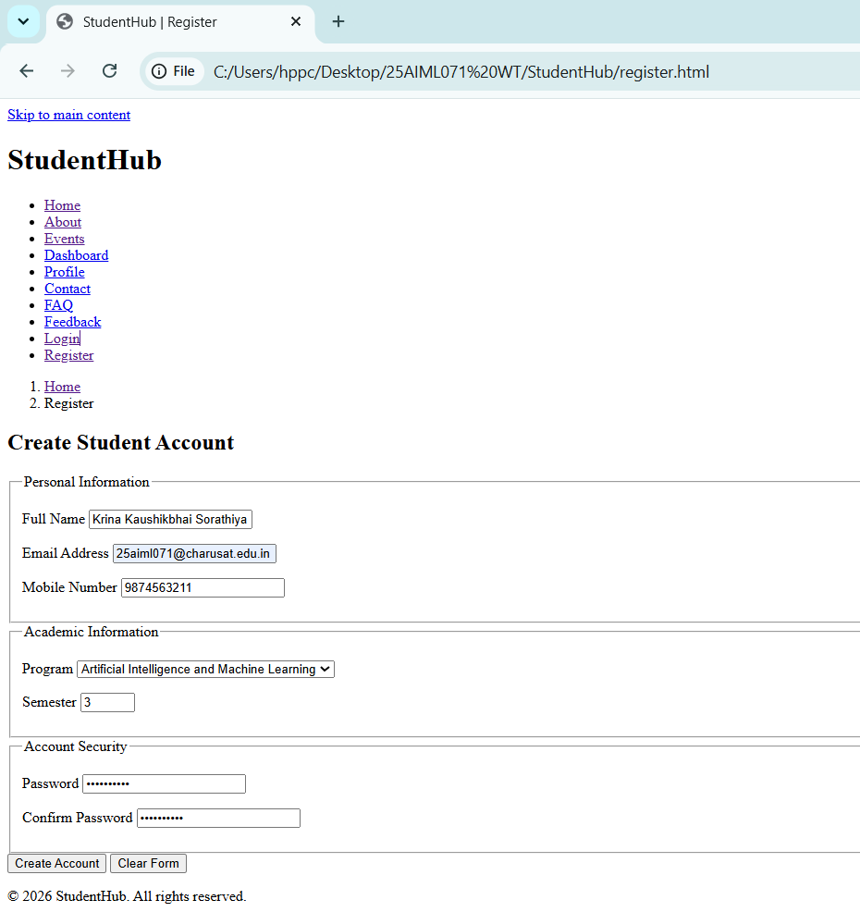

Dashboard with quick link

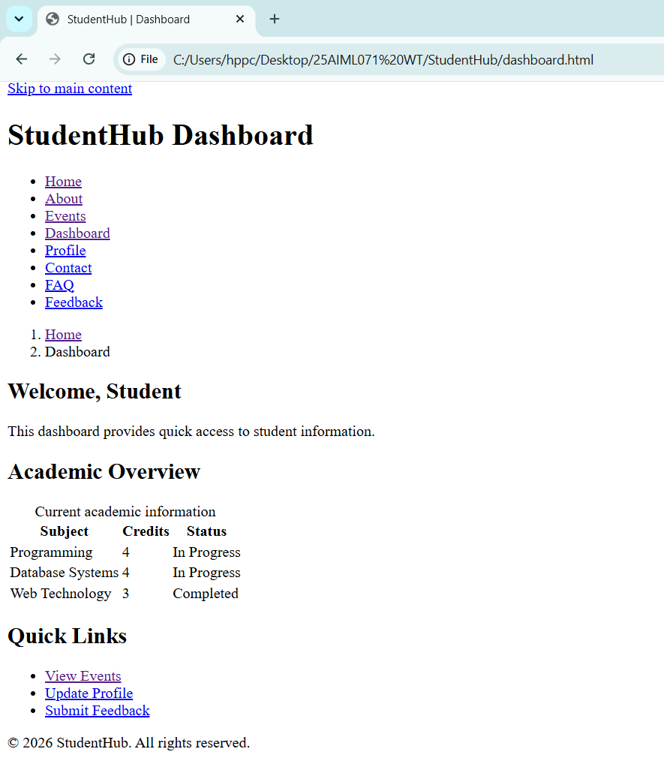

Profile

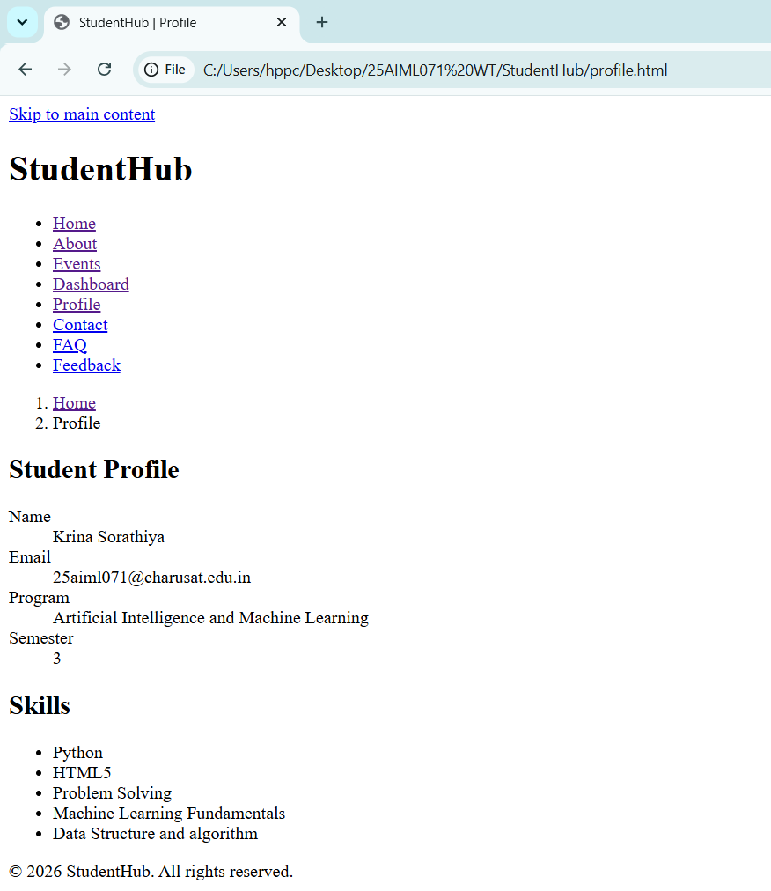

Contact

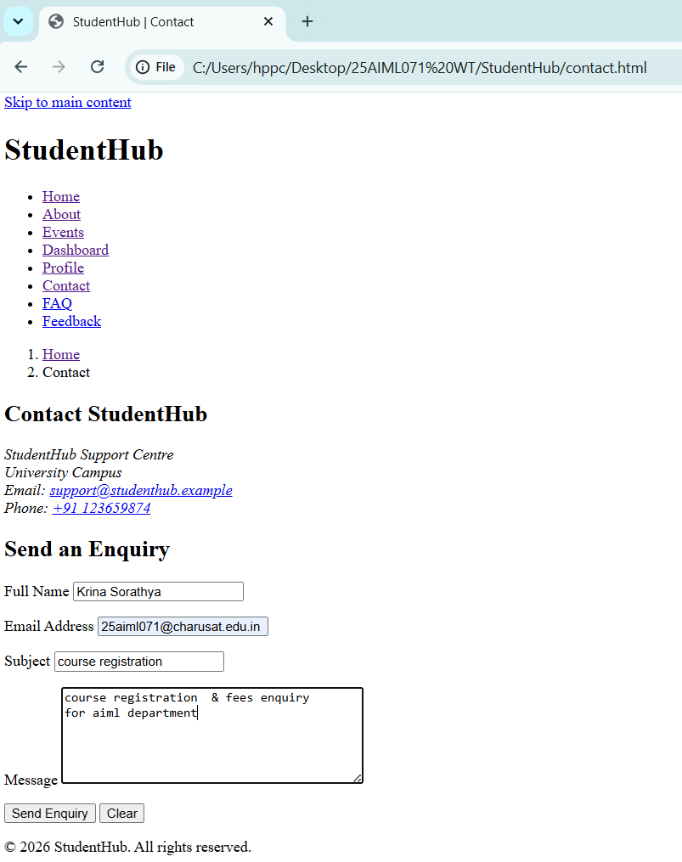

Admin & FAQ

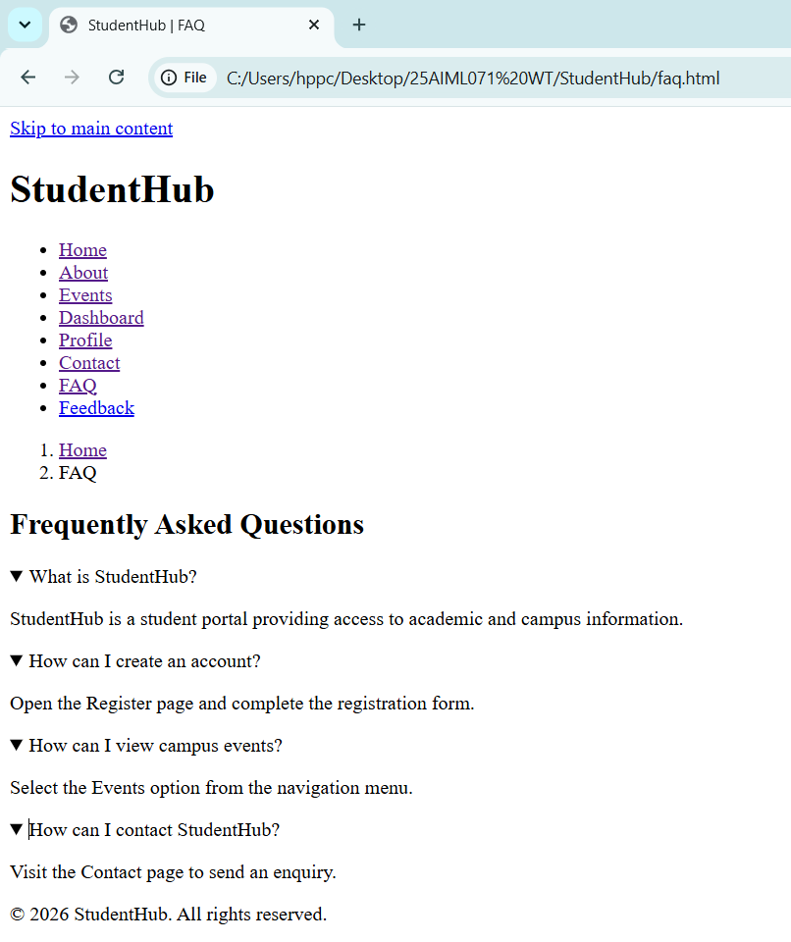

Feedback

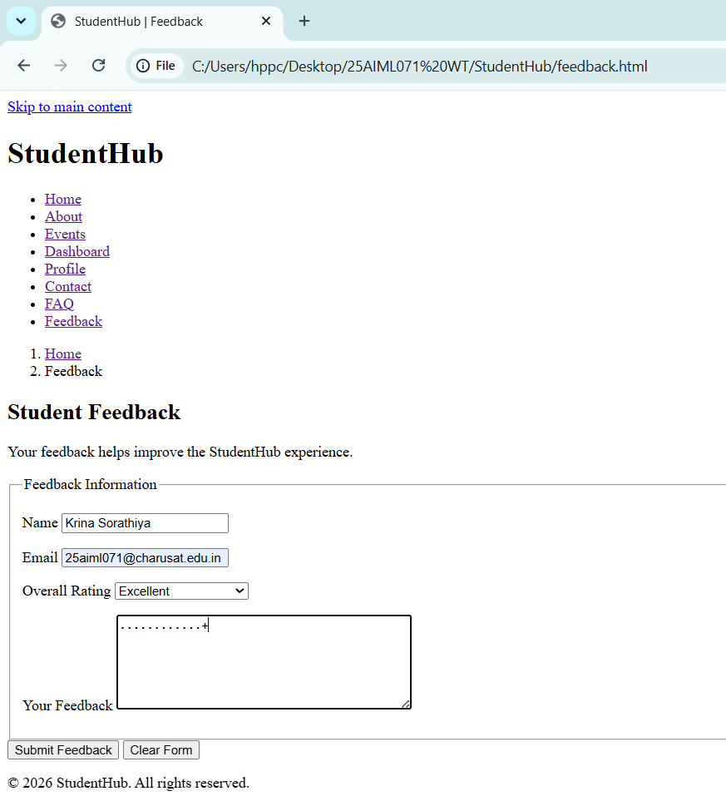

Learning Outcome:
- Students will create clean, linked, and accessibility-ready HTML page structures.

References:

- MDN Web Docs – HTML5 Semantic Elements and Accessibility.
- HTML5 Documentation – Semantic Elements and Forms.
- W3C Web Accessibility Guidelines – Accessible Web Content.
- Classroom notes and Practical 2 guidelines.

